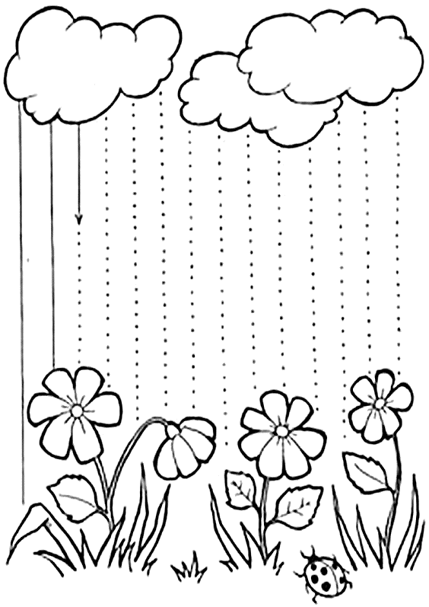

Zdroj: https://tulamama.com/tracing-lines-worksheets/
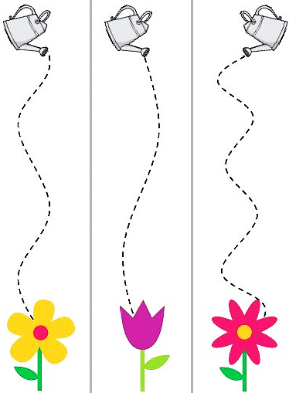

Zdroj: https://www.soumae.org/atividades-infantis-tema-jardim/

